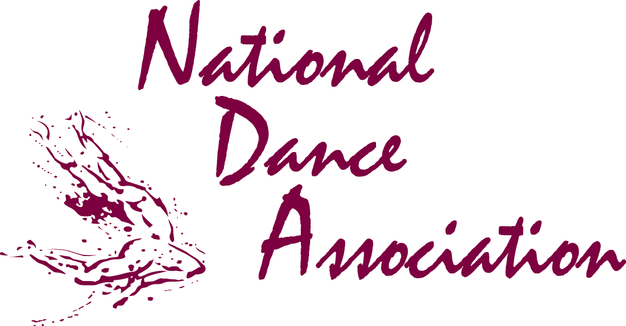
FOR IMMEDIATE RELEASE
Media contacts:
Paula Keyes Kun (703) 476-3461; pkun@aahperd.org
Sinu Patel (703) 476-3485; spatel@aahperd.org
@NDA_AAHPERD
NDA on Facebook

AWARD-WINNING DANCE ARTISTS WILL EMPOWER SCHOOLS AND COMMUNITIES TO MOVE AND LIVE HEALTHY LIVES THROUGH DANCE
AUGUST 2-4 IN NORFOLK

RESTON, VA, June 1, 2012— CNN American Hero Fabian Barnes of the Dance Institute of Washington, Dr. Joyce Paul Poursabahian, an international Bharatanatyam Indian classical dancer, and 2007 Dance Teacher Magazine K-12 Teacher of the Year Freddie-Lee Heath are among the professional dancers, teachers and choreographers who will help “Empower Communities to Move and Live Healthy Lives through Dance,” during the National Dance Association’s (NDA) Dancing for Health and Wellness Pedagogy Conference in Norfolk, VA. To take place August 2- 4 at Norfolk State University, the conference is designed to excite and educate physical education, health education and dance instructors on using dance to motivate their students to embrace a healthy lifestyle and educate dancers on how to maintain their own health despite injury and stress.
“Dance education programs in the public school system have been on a steep decline, from 20 percent to just three percent in the last 10 years, according to a national arts survey by the National Center For Education Statistics. Our goal is to reach out to physical educators, health and dance teachers and recreational professionals to encourage them to help keep dance on the forefront of health and wellness programs in both schools and communities nationwide,” says Colleen Dean, NDA program manager. “Dancing is ideal for any age and has been shown to have a positive impact on how well people learn and process information, from students to older adults.”
This year’s conference will include a Let’s Move in School (LMIS) component geared towards early childhood. Freddie-Lee Heath, one of the first dance educators to achieve National Board Certification (NBCT) in physical education, will teach a group of area daycare students a dance they will perform during the conference’s Let’s Move—Let’s Dance showcase. LMIS is an education initiative of the American Alliance for Health, Physical Education, Recreation and Dance (AAHPERD), NDA’s umbrella organization, and aims to ensure students have opportunities to be physically active before, during, and after school.
Highlighting new ways of learning and teaching about the correlation between dance and health, the conference will also present the latest research on the art form and hold leadership and advocacy sessions regarding policies that utilize dance education as a preventive, anti-obesity tool in schools and communities.
The meeting is in collaboration with the Southern District AAHPERD, Virginia AHPERD, its collegial associations, the Department of Health, Physical Education, and Exercise Science at Norfolk State University (NSU) and NSU's Health and Wellness Initiative for Women.
To register for the conference, view a full list of guest presenters, and learn about their background, visit NDA’s conference page. In the coming weeks, refer back to the NDA website for finalized program sessions and workshop schedules. Dance education contact hours are available through NDA and CHES/MCHES credits are available through the American Association for Health Education (AAHE).
Highlights of Sessions and Guest Presenters
Dr. Joyce Paul Poursabahian, Arpan (Bharatanatyam Institute), Redmond, WA, “The Basic Technique and Dynamics of Natyam” Classic Indian dance 101—participants will get the basics of the art form down and learn mandalas (positions), adavus (units of movement), talams (rhythm cycles) & mudras (single/double-handed gestures) that make up the primary vocabulary of Bharatanatyam.
Dr. Susan Biali, Vancouver, Canada, “It's Never Too Late! A Flamenco-Dancing Doctor's Secrets for a Healthier, Happier, More Passionate Life” This award-winning doctor, life coach and flamenco dancer will share lessons in life, dance, and health from her internationally recognized journey as a "mature" dance student.
Fabian Barnes, Dance Institute of Washington, Washington, DC, “Ballet Technique—An Enriching Experience” The former soloist with the Dance Theatre of Harlem and the recipient of the National Arts and Humanities Youth Program Award will teach the power of a plié! In this class, attendees will learn about the health benefits of ballet and what is considered the proper alignment and placement along with musicality, agility, spatial and kinaesthetic awareness.
Freddie-Lee Heath, Enloe High School, NC, “Teaching Them Where They Live or It’s All About the Hook” Teachers will explore both the technical and creative components of dance at the middle school level. Participants will walk away learning a variety of movements to show students with little to no dance experience how to feel confident in their steps, learn how to evaluate students with an easy to follow rubric and how students can realize their own potential.
Greacian Goeke, San Francisco, CA, “Freeing the Dancer Within” An experimental workshop where participants will learn creative movement curriculum for elder adults. The workshop is based on improvisation, reflection, and a "move it or lose it" philosophy. Perfect for community health and wellness programs!
Josie Metal-Corbin, University of Nebraska-Omaha, “Dancing in Place: Site-Specific Work” Josie Metal-Corbin will chronicle four decades of her experience working with artists, educators, librarians and scientists. From zoos to deep in prairie grass, she will help participants discover the hidden meaning in the spaces around them.
Kadidia V. Doumbia, International Dance Council-UNESCO, Northern GA, “Dance as a Way of Living” This independent dance teacher and choreographer will inspire attendees through her dance philosophy--dance is part of every culture on earth. It unites people in joy and sadness. It is through dance that generations are united. She will share the latest research on how dance has the power to create a common understanding that cultures can share throughout the world.
Lida Winfield, Flynn Center for the Performing Arts, Burlington, VT “In Search of Air” Participants will learn innovative approaches for hands-on type of learners/students and use spoken word and dance to demonstrate different ways to transform learning for students with and without disabilities.
About National Dance Association (NDA)
The National Dance Association is a members-driven organization that advocates for dance education as a creative, healthy lifestyle that benefits people of all ages and abilities. NDA promotes and supports creative and healthy lifestyles through high quality dance programs and furthering knowledge and sound professional practices in dance education. It is one of five national associations within the American Alliance for Health, Physical Education, Recreation and Dance (AAHPERD). To learn more about NDA, visit www.aahperd.org/nda.
About American Alliance for Health, Physical Education, Recreation and Dance (AAHPERD)
AAHPERD, an alliance of five national associations, six district associations, and a Research Consortium, provides its members with a comprehensive and coordinated array of resources, support, and programs to help practitioners improve their skills to further the health and well-being of the American public. It is the largest organization of professionals involved in physical education, recreation, fitness, dance, health promotion and all specialties related to achieving an active, healthy lifestyle. AAHPERD serves 20,000 members and has its headquarters in Reston, Virginia, 25 miles west of Washington DC. For more information, visit www.aahperd.org.
-30-

